Description of the ETL pipeline:

I used 2 files: main.py and sqlserver_connection.py

The ETL process starts by importing the necessary packages:  
requests for making HTTP requests using the 'get' function, pandas for utilizing data frames,   
sqlserver_connection which is a file I created to define the connection to my SQL server DB,   
for that I used sqlalchemy and urllib.

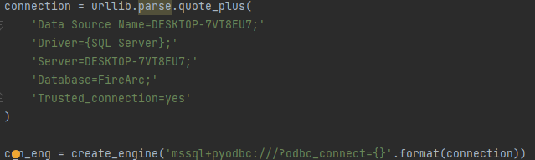  
to apply a connection SQL server and datetime so I'll be able to add datetime column.

The first action is to pick a json URL of the dataset through apidocs:  
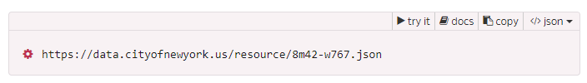

I used 'get' function out of requests and I limited the request to 10k rows to avoid ram overuse.  
Next, I created a data frame from the JSON data to make it compatible with SQL usage.  
Next, I've added a datetime column to track inserted data.

Finally, I use the pandas 'to_sql' function to stream the data into the database.  
